##$$KK>>Talpha'/Alpha-Method

This program plots the lengths of isogons of a fold, normatized with the distance of of two layers in the hinge versus the angle of dip of the isogons. Parallel folds produce a horizontal line. Similar folds plot as a cosine function (RAMSAY, 1967).

##$$Talpha'/Alpha Method, Manual Data Input

First you have to put in the distance between two layers in the hinge for each fold, then put in the lengths of the isogons-in steps of ten degrees. The input is listed in the table on the right side.
Data can be saved in a file with the extension ‚.TAL‘. Only the ratios T/T0. are saved.
##$$Talpha/Alpha'-Method, Data Input from a File

After pressing the button 'Start' the list field on the right side ('select files') shows the content of the directory whose path is saved in Fabric7.ini. If this field is empty and the message 'no file found' appears, the data path can be changed after pressing the button 'find data path'.
Click on the files you want to use. These files appear in the middle field ('selected files'). Files can be removed from this list by clicking on them.
The button 'plot' opens the plot form. The data of the files used appears in the left field.
The extension of the files and the path chosen appear under the left list.
The button "plot" opens the graphic form.
##$$Talpha'/Alpha Method, Plot

The ratio Talpha'/T0 is plotted versus the angle of the isogons (Talpha' = length of an isogon, T0 = distance between two layers in the fold hinge). The curves for an ideal parallel fold (horizontal line) and for an ideal similar fold (cosine function) are drawn.
colour and line type can be changed.
##$$KK>>Isogon

An isogon connects tangential points between the upper and lower bedding plane of a fold with two parallel lines.

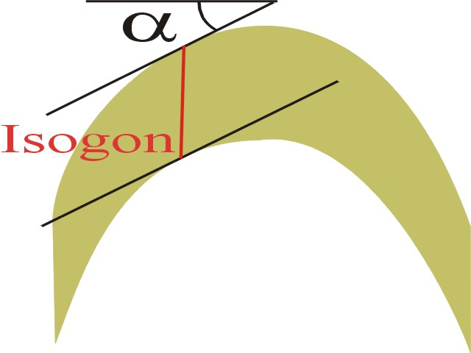
##$$Data Input from a Bitmap

A picture of the folded layers must exist as a pixel-graphic (*.bmp oder *.jpg) in a file or on the clipboard. In order to draw the isogons ,the axial plane of the fold must be in vertical position. First click an a piont which shall become the new centre of the graphic, then press the button "New Centre point". Then click on the hinge point of a folded layer and press the button "1st point" Do the same with the second folded layer. The program will rotate the fold and the two points are now in a vertical position. Instaed of the cursor, a straight line with inclination of 10° with a point on it appears. Drag this line until this point becomes the point of contact with the fold, then press the button "1st point". Do the same with the second folded layer. Now the isogon is plotted, and a line with inclination of 20° appears. Do the same procedure with this tangent. In this way all possible isogons are plotted. When the angle becomes so steep that no Tangent is possible, press the button "end". Open the graphic form with the button "plot".

# Talpha
$ Talpha
K Talpha'/alpha method
> Hilfe1
# TalphaManuell
$ TalphaManuell
# TalphaDiskette
$ TalphaDiskette
# TalphaPlot
$ TalphaPlot
# Isogone
$ Isogone
K isogon
> Hilfe1
# TalphaBitmap
$ TalphaBitmap

